1) (2pts) Chapter 3 Text Book Problem 15. For your answer, list the bridge, each of the bridges interfaces and then the nodes the bridge knows are reachable through that interface.
Example: Bridge 1 has two interfaces A-Interface and B2 interface, on the A-interface node A is the only possible node it can learn, on the B2-interface it is possible for B1 to learn about nodes C and D. After the three transmissions, determine which nodes are known to each bridge and on what interface. Look at problem 3-16 for some extra help.

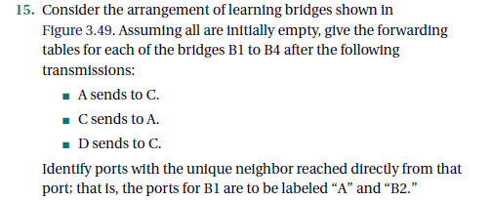
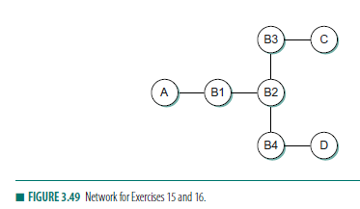
2) (2pts) Chapter 3 Text Book Problem 17 – remember as each bridge learns where a node is it forwards traffic for the node on the one link only. The first transmission requires all bridges to forward a packet out on all links. After that transmission, some bridges will selectively forward packets.

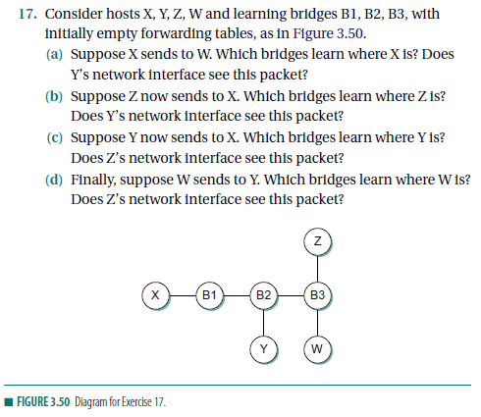
3) (2pts) Chapter 3 Text Book Problem 46 (Distance Vector Routing Protocol)

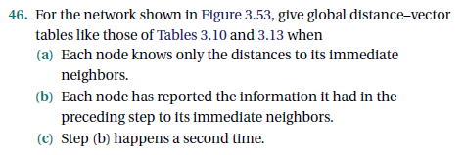

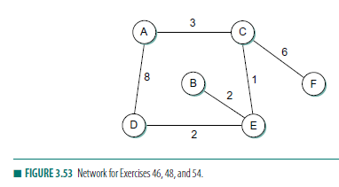

4) (2pts) Chapter 3 Text Book Problem 62

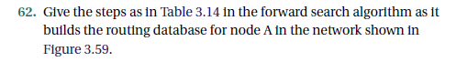
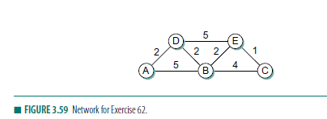
5) (2pts) Chapter 3 Text Book Problem 55
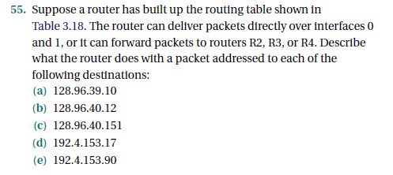
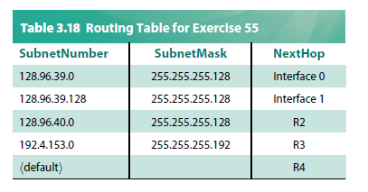

Optional
6) (Not graded) Chapter 3 Text Book Problem 52
